LAB EXPERIMENT RECORD
SET 17: EMPLOYEE PERFORMANCE ANALYSIS
Department | AIDS
Course Code / Course Name | DSA0601 / Data Handling and Visualization
Experiment | Data Visualization using R
Name | B. Pallavi
Register Number | 192424243
Date | 13 October 2026
Day | Tuesday

AIM
To analyze employee performance scores and departmental distribution using R and Tableau.
DATASET
Employee ID | Department | Years of Service | Performance Score
1 | Sales | 5 | 85
2 | HR | 3 | 92
3 | Marketing | 7 | 78
PROGRAM 1: LINE CHART OF PERFORMANCE SCORE
R Code
years <- c(5, 3, 7)
score <- c(85, 92, 78)
order_index <- order(years)
plot(years[order_index],
score[order_index],
type = "o",
main = "Performance Score vs Years of Service",
xlab = "Years of Service",
ylab = "Performance Score",
col = "blue",
pch = 16)
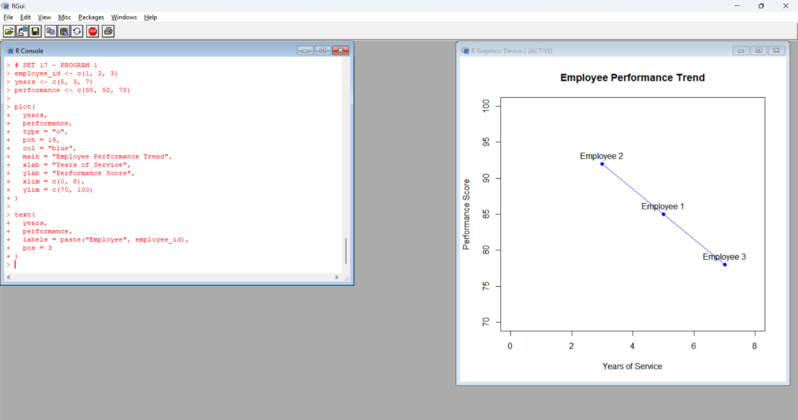
Observation: The employee with 3 years of service has the highest performance score of 92. The employee with 7 years of service has the lowest score of 78.
PROGRAM 2: BAR CHART OF EMPLOYEE DEPARTMENTS
R Code
department <- c("Sales", "HR", "Marketing")
department_count <- table(department)
barplot(department_count,
main = "Employees by Department",
xlab = "Department",
ylab = "Number of Employees",
col = "lightgreen")
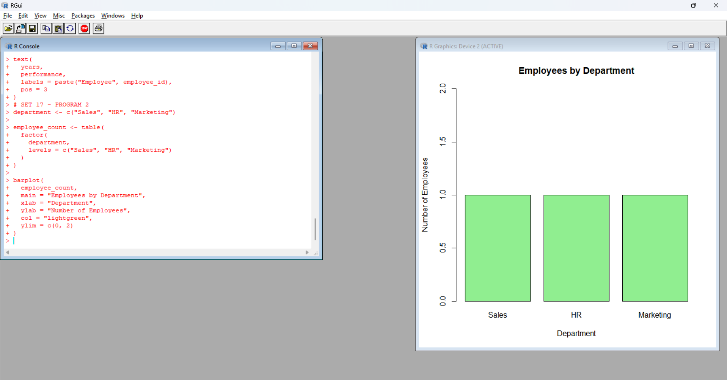
Observation: Each department has one employee in the given dataset.
PROGRAM 3: DISPLAY EMPLOYEE DATA
R Code
employee_data <- data.frame(
Employee_ID = c(1, 2, 3),
Department = c("Sales", "HR", "Marketing"),
Years_of_Service = c(5, 3, 7),
Performance_Score = c(85, 92, 78)
)
print(employee_data)
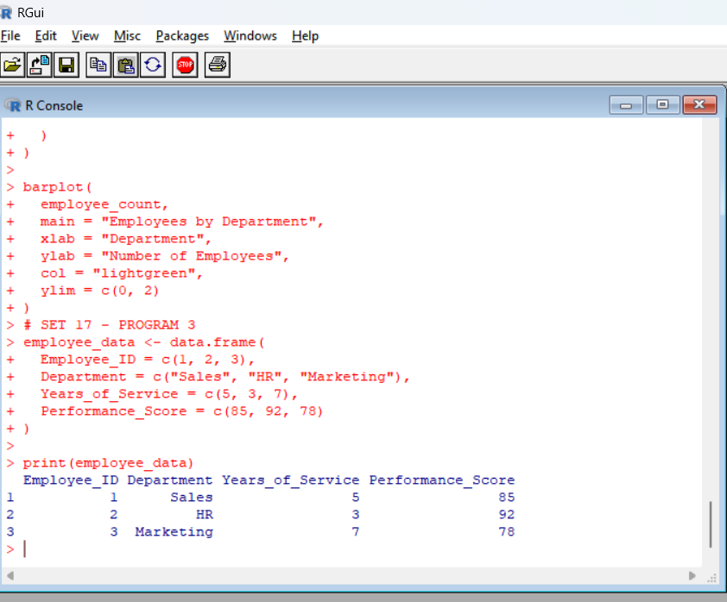
Observation: The data frame displays employee details, years of service, and performance scores.
PROGRAM 4: CREATE A TABLEAU DASHBOARD
- Enter the employee dataset into Excel.
- Save the file as Employee_Performance.xlsx.
- Open Tableau and connect to the Excel file.
- Create a chart comparing performance scores with years of service.
- Create a bar chart showing employee counts by department.
- Add the employee data table.
- Combine all visualizations into a dashboard.
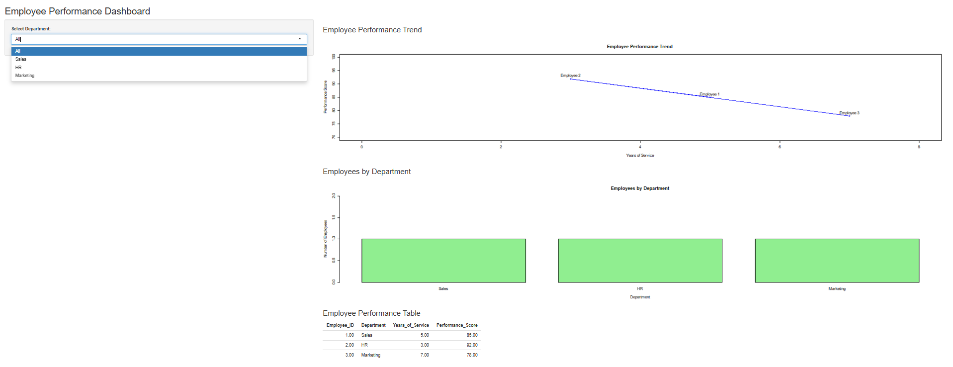
Observation: The dashboard provides a visual summary of employee performance and departmental distribution.
PROCEDURE
- Open R or RStudio.
- Enter the employee dataset.
- Execute each R program.
- Observe the charts and data table.
- Create the dashboard in Tableau.
RESULT
Employee performance data was analyzed successfully using R and Tableau. The visualizations displayed performance scores, departmental distribution, and employee details.

